Audit - Assessment
Food Business Details
Proprietor Name | Regis Aged Care | Date/Time of Audit | Wed 20/05/2026 at 9:30am
Trading Name | Regis Dandenong North | Phone Number | 03 9701 1244
Business Address | 5 Bakers Road Dandenong VIC 3175
Business Contact | Bryan Seeborun  Aurelie Flack | Contact Email | bseeborun@regis.com.au  aflack@regis.com.au
Person in Charge | Helen Santoreneus | Contact Email | dandenong@regis.com.au
Nominated FSS | Sunil Kumar/ Damith Yagamuni
Premise Type | Aged Care | Class | 1
Council Details
Council/Shire | City of Greater Dandenong | Registration No. | F-2247 Expiry Date 31/12/2026
Council Email | council@cgd.vic.gov.au

Auditor Details
Name | Narmada Oogathoo | DHHS Reg. | 00224045
Auditor Phone | +61402701166 | Auditor Email | stryve@outlook.com.au

Audit Details
Date of Previous Audit | 15/05/2025 | Date of Current Audit | 20/05/2026
Scope & Objective | Third Party Food Safety Audit to Assess the level of Compliance of the Regis Dandenong North Food Safety Management System in meeting the requirements of FSANZ Standard and Vic Act 1984.
Reference Standard | 3.2.1- Provides information regarding Food Safety Programs  3.2.2- Provide standard for Food safety practices and general requirements  3.2.3- Provides the standards for food premises and equipment  3.3.1- Provide information on Food Safety Program for Food Service for Vulnerable Persons
Type of Audit | Adequacy and Compliance Audit
Rating Codes | Compliant: Y  Observation: OBS  Non-Critical Deficiency: N  Critical Deficiency: C

Audit terminology & references:
Food Safety Program/ Plan: A document that systematically examines all of the food handling operations of a food business in order to identify potential hazards. These hazards, once identified, must be controlled with an identified means of control and provision made for systematic monitoring of these controls. The identification and monitoring of these controls are in accordance with the relevant legislation, i.e., the Victorian Food Act - 1984 and the FSANZ standards. The Food Safety Program/ Plan must be held on the food premises and must be audited annually by an accredited 3rd Party Food Safety Auditor.
Compliance (Y)
States that the food safety program is adequate and there is evidence of compliance with the food safety program and other requirements. It refers to satisfactory evidence that all aspects of the food operation operate in accordance with the Food Safety Program/ Plan and legislative requirements.
Observation (OBS)
Refers to those parts of the food business operation that is Compliant (S) but where there may be an opportunity for improvement. Observations may lead to deficiencies in the long term if left unattended.

Non-critical deficiency (N)

This is a deficiency that is not considered to be a critical deficiency. This is a low-risk situation where the potential impact of the deficiency is not likely to be a serious or imminent risk to public health. An appropriate time frame for the rectification of the deficiency must be negotiated with the auditor who will then follow it up to ensure that it has been rectified. A non-critical deficiency can lead to a critical deficiency if it is not rectified. The Local Government Authority is not notified in this instance.

Critical Deficiency (C)
A critical deficiency is an inadequacy in the food safety program or a failure to comply to a food safety requirement that may lead to a serious risk of food being sold or prepared that is unsafe or unsuitable. The local government authority must be notified immediately by telephone and followed up with written confirmation within 24 hours. The Local Government Authority ensures that actions are taken to remove the risk to public health and will liaise with the Food Safety Auditor to ensure that the issue has been closed off.
FSANZ: Food Standards Australia New Zealand is an independent statutory agency established by the “Food Standards Australia New Zealand Act 1991” and whose ultimate goal is to ensure a safe food supply for consumers. Further information regarding the standards and any updated information can be found at: www.foodstandards.gov.au
FSANZ Food Standards Code: www.foodstandards.gov.au/thecode/foodstandardscode
Victorian Food Act: The Victorian Food Act is legislation introduced by the Victorian State Government in 1984, and subsequently amended, whose goals are in concert with FSANZ, i.e., to ensure a safe food supply for Victorian consumers. Victorian health services are administered by the Victorian Department of Human Services and further information regarding the Food Act, including any updated information, can be found on the Victorian Government Health Information Web site: www.health.vic.gov.auThe Victorian Food Act: https://content.legislation.vic.gov.au/sites/default/files/2022-12/84-10082aa115-authorised.pdf
Local Government Authority: A copy of the Food Safety Program/ Plan must be lodged with the Local Government Authority and any amendments to the document must be submitted within 14 days. A copy of the cover page report and your audit certificate has been sent to your Health Officer by the auditor. If they request a copy of this report, you will need to oblige.
Further information regarding both FSANZ & the Victorian Food Act, together with any relevant local government requirements, can be obtained from your Environmental Health Officer (E.H.O.).

Activity audited |  | FSP Ref | Compliance  Y/N/OBS/C | Evidence/reasons for compliance OR non-compliance | Action taken or proposed to be taken | Agreed completion date
STANDARD 3.2.1 FOOD SAFETY PROGRAM & VIC FOOD ACT 1984
Food safety program | Flowchart | 18 | Y | The flow diagram included in the Food Safety Program accurately outlines all operational processes and steps required for hazard analysis. It provides a comprehensive and logical representation of the food handling procedures, ensuring all critical control points and activities are effectively documented and addressed:  - Menu Design/Purchasing  - Delivery  - Storage  - Cold  - Frozen  - Ambient  - Preparation Processes  - Time out of temperature  - Sanitation of melons  - Thawing  - Heat Treatment Process  - Reheating  - Cooking  - Cooling  - Texture Modifications  - Transport  - Hot Holding  - Plating/service  - Washing Up |  |  | Click or tap to enter a date.
Food safety program | Hazard Identification Hazard Control  Monitoring  Corrective Actions | FSP Ref:  19 - 39 | Y | HACCP plan is based on Codex Alimentarius Commission’s HACCP Principles and guidelines and section 19D of the Food Act 1984  The Food Safety Program (FSP) identifies microbiological, physical, and chemical hazards and incorporates a HACCP framework with defined Critical Control Points (CCPs), critical limits, and corrective actions. Control measures and monitoring procedures clearly specify responsibilities, methods, and frequency. Corrective actions for deviations are documented to ensure compliance and maintain food safety |  |  | Click or tap to enter a date.
Food safety program | Flowcharts |  | Y | The Food Safety Program (FSP) flowchart is detailed and accurately reflects all key food handling processes.
Food safety program | Internal review | FSP Ref:  99 | Y | In accordance with the Food Safety Program, regular reviews are undertaken, including quarterly internal food safety audits conducted by the Food Safety Supervisor.  Internal Audit Report sighted for 11/02/25 and 20/05/2025 |  |  | Click or tap to enter a date.
Food safety program | Annual review | FSP Ref:  99 | Y | The Current Food Safety Program (V3 2026) was reviewed in January 2026 by the National Food Safety Representative. |  |  | Click or tap to enter a date.
STANDARD 3.2.2 FOOD SAFETY PRACTICES AND GENERAL REQUIREMENTS - Division 2 — General requirements
3 General requirements | Food handling skills and knowledge | FSP Ref: 95 | N | All food handlers have received appropriate training, with individual training records maintained with Administration Team.  However, the following issues identified reveal a lack of knowledge in food safety measures:  - The designated hand wash basin was being used for purposes other than hand washing and was obstructed by dirty dishes and cleaning materials, limiting accessibility for effective hand hygiene practices (Fig 1).  - Single-use containers and food-grade containers were being reused for cleaning purposes, creating a risk of cross-contamination and misuse of food contact equipment (Fig 2, 9, 30).  - Resident meals stored within a dedicated refrigerator were identified by resident details; however, no use-by or discard date labelling was provided to support safe food storage and stock rotation practices (Fig 11).  - Condiments stored on service trolleys remained uncovered when not in active use, exposing the products to potential contamination (Fig 18).  - Food items stored within the refrigerator were not adequately covered, increasing the likelihood of contamination during storage (Fig 28).  - Serving scoops were stored in direct contact with dry food products, creating a potential contamination risk (Fig 48).  - Opened food packets had not been transferred into sealed food-grade containers after opening, reducing protection against contamination and pest activity (Fig 49).  - Food items with a limited shelf life after opening were retained beyond their nominated use-by period (Fig 53).  - Food items stored within the dry store and coolroom were placed directly on the floor, hindering effective cleaning and increasing contamination risks (Fig 50, 51). | Remove dented cans from stock and implement inspection procedures for incoming goods.  Provide photographic evidence and staff training records.  Ensure all hand wash basins are maintained exclusively for hand washing purposes and remain unobstructed at all times.  Implement effective food storage and labelling procedures to ensure food is protected from contamination and appropriately identified throughout storage and use.  Store all food and food-related items off the floor on suitable shelving or pallets to facilitate cleaning and prevent contamination.  Provide photographic evidence and staff training records. |  | 28/08/2026
STANDARD 3.2.2 FOOD SAFETY PRACTICES AND GENERAL REQUIREMENTS – Division 3 — Food handling controls
5 Food receipt | Purchasing | FSP Ref:  72 | Y | Food is only being sourced from reputable approved suppliers, having a high standard and registered or licensed with the relevant regulatory agency. |  |  | Click or tap to enter a date.
5 Food receipt | Approved Suppliers List / Agreement | FSP Ref: 72 | OBS | The Food Safety Program includes an Approved Supplier List and Certification from Approved Suppliers, which are accessible from the portal of a new established software system Simple.  Copies of certificates that sighted for review during the audit:  Tiptop Bakery – Valid until 31.12.2026  Bega – Valid until 24.05.2027  PFD – Valid until 11.05.2026  360 Degrees Meat – Valid until 20.07.2028  Provincial Produce – Valid until 30.09.2025  Details of service providers, including the pest control provider were not available on Simple portal at the time of the audit. |  |  | Click or tap to enter a date.
5 Food receipt | Receival of food | FSP Ref:  44 | Y | Product deliveries are only accepted from approved suppliers.  Products are checked upon arrival. Food suitability, used by date and packaging conformity are confirmed, temperature of chilled goods is recorded, condition of frozen good are checked for sign of thawing and record are kept in the Delivery Module.  Any non-conformances are reported, then action by Catering Manager to close out corrective actions.  Product Receiving Sheet 4.8.40 were reviewed from 01.06.2025 to 31.07.2025.  Simple Portal Record reviewed from 01.09.2025 to 31.01.2026 with compliance rate of 99.69%  The Food Safety Program requires that at each delivery, both a high-risk food item and a frozen food item are checked to verify compliance with temperature requirements and delivery vehicle are routinely checked. |  |  | Click or tap to enter a date.
6 Food storage & Equipment  Temperature monitoring | Dry Storage | FSP Ref:  46-52 | Y | Adequate storage facilities available with all food covered and labelled with identification and used by dates.  Foods remaining in its original packaging are stored in rodent proof sealed containers to prevent cross contamination. |  |  | Click or tap to enter a date.
6 Food storage & Equipment  Temperature monitoring | Cold Storage  Cool room  Freezer  Refrigerator | FSP Ref: 46-52 | OBS | The facility is equipped with adequate refrigeration storage. The cool room was well-stocked, with sufficient space maintained to support proper air circulation and temperature control.  Equipment Temperature Logs (Form 4.8.28/29) from 01.06.2025 to 31.07.2025 were reviewed.  Simple Portal Record reviewed from 01.09.2025 to 31.01.2026 with a compliance rate of 98.10%.  Records reviewed were generally compliant; however, few records were completed outside the required timeframe with corrective actions completed.  Few gaps were identified in serveries, with few dates’ temperature recorded above 6 degrees in Kingfisher, without corrective actions.  Note that issued are resolved with the introduction of Simple Digital Monitoring process. |  |  | Click or tap to enter a date.
6 Food storage & Equipment  Temperature monitoring | Frozen Storage Freezer | FSP Ref: 46-52 | Y | All freezer stock is appropriately labelled with dates and identification. Frozen items remain solid, without any signs of thawing.  Records of Equipment Temperature Logs (Form 4.8.28/29) were reviewed from 01.06.2025 to 31.07.2025, and no gaps were identified.  Simple Portal Record reviewed from 01.09.2025 to 31.01.2026 with a compliance rate of 98.10 %.  Records reviewed were generally compliant; however, few records were completed outside the required timeframe with corrective actions completed |  |  | Click or tap to enter a date.
7 Food processing | Thawing | FSP Ref: 53 | Y | Minimal thawing is conducted on-site; however, when requires, staff ensure the process is carried out under controlled temperatures in the cool room, with appropriate labelling.  Records of Thawing Logs (Form 4.8.41) were reviewed from 01.06.2025 to 31.07.2025, and satisfactory records sighted. |  |  | Click or tap to enter a date.
7 Food processing | Preparation | FSP Ref: 55 | OBS | Staff were observed wearing appropriate protective clothing, including clean uniforms, hats, aprons, and gloves. A calibrated temperature probe was available. Jasol Fruit Wash in use for sanitising ready-to-eat fruit and vegetables.  Simple Portal Record reviewed from 01.09.2025 to 31.01.2026 with a compliance rate of 94.59%.  Records are documented in double-digit values for the period audited despite the test kit only measuring and requiring whole number readings.
7 Food processing | Cooking | FSP Ref: 63 | Y | Core Cooking temperature of Potentially Hazardous Foods are monitored daily to ensure elimination or reducing of harmful bacteria during the process.  Clean and sanitised Temperature probe is used to check temperature.  Monitoring Temperature Log – Kitchen (Form 4.8.38) were reviewed from 01.06.2025 to 31.07.2025  Simple Portal Record reviewed from 01.09.2025 to 31.01.2026 with a compliance rate of 99.95%. |  |  | Click or tap to enter a date.
7 Food processing | Cooling | FSP Ref: 65 | OBS | Cooling of potentially hazardous food is conducted on-site as needed.  Chilling, Cooling, and Freezing Log (Form 4.8.26) were reviewed from 01.06.2025 to 31.07.2025 were found to be compliant, with products cooled to below 5°C within the required 2-hour timeframe. However, every day cooling has the same start and finish time.  Simple Portal Record reviewed for Cooling from 01.09.2025 to 31.01.2026 with compliance rate of 83.02%.  Records reviewed were generally compliant; however, gaps were identified with corrective actions completed. | Reinforce staff responsibilities for completing all required checks, provide refresher training where necessary, and conduct regular supervisory reviews to improve and maintain compliance rates.  Provide staff training records. |  | 28/08/2026
7 Food processing | Reheating | FSP Ref: 67 | Y | Core Reheating temperature of Potentially Hazardous Foods are monitored daily to ensure elimination or reducing of harmful bacteria during the process.  Monitoring Temperature Log – Kitchen (Form 4.8.38) were reviewed from 01.06.2025 to 31.07.2025 and satisfactory records sighted.  Simple Portal Record reviewed from 01.09.2025 to 31.01.2026 with compliance rate of 100%. |  |  | Click or tap to enter a date.
7 Food processing | Vitamising / Texture Modification | FSP Ref: 55 | Y | Ready-made Texture-modified meals are purchased from Pure Foods, however, for ad hoc preparation, Robot Coupe Blixer is used to puree foods to the desired consistency.  Relevant IDDSI Standard are applied for Texture Modified Meals.  According to Food Safety Program, processing equipment must be clean thoroughly prior to use to prevent microbiological, allergen and physical contamination. |  |  | Click or tap to enter a date.
8 Food display | Hot holding | FSP Ref: 68 | Y | Hot holding of cooked or reheated foods is carried out using bain-maries located in Main Kitchen and Serveries  Bain-maries are preheated prior to service, and food temperatures are maintained above 60°C for a maximum duration of two hours.  Food is held at a hot holding temperature of ≥60°C and for a maximum of 2 hours  Average serving time of 30 mins to 1 hour, which is not sufficient to allow pathogen growth. |  |  | Click or tap to enter a date.
8 Food display | Cold holding | FSP Ref: 71 | Y | Food is held at cold holding temperature of <5°C in fridge before service. Average serving time of 30 mins to 1 hour, which is not sufficient to allow pathogen growth. |  |  | Click or tap to enter a date.
8 Food display | Service of Food | FSP Ref: 71 | Y | Serving of meals were not sighted during the audit.  However, staff were observed wearing appropriate PPE prior to service, including gloves.  A range of serving utensils were sighted and crockeries/cutleries were found in good condition.  Simple Portal Record reviewed from 01.09.2025 to 31.01.2026 with compliance rate of 100%. |  |  | Click or tap to enter a date.
10 Food transportation | Transport of food | FSP Ref: 69 | Y | Food is transported in clean and sanitised trolley for service.  Food is transported in clean gastronome trays with fitting lids to prevent cross contamination.  Transportation time is within 10 mins from Main Kitchen. |  |  | Click or tap to enter a date.
11 Food disposal | Food for disposal | FSP Ref: 86 | Y | No food designated for disposal was observed during the audit.  However, the Food Safety Program includes comprehensive documentation outlining the food disposal process, which is readily accessible to all food handlers. |  |  | Click or tap to enter a date.
12 Food recall | Food recall | FSP Ref: 86 | OBS | No food designated for food recall was observed during the audit.  However, the Food Safety Program includes comprehensive documentation outlining the food recall process, which is readily accessible to all food handlers.  A designated food recall area was not identified at the time of the audit. |  |  | Click or tap to enter a date.
STANDARD 3.2.2 FOOD SAFETY PRACTICES AND GENERAL REQUIREMENTS - Division 4 — Health and hygiene requirements
14 Health of food handlers | Health of food handlers | FSP Ref:  74 | Y | Staff illness register is managed by the Administration Team.  and record maintained accordingly.  Any reported food borne illness is accompanied with relevant staff details and medical certificates. |  |  | Click or tap to enter a date.
15 Hygiene of food handlers | Hygiene of food handlers | FSP Ref: 74 | Y | Appropriate personal hygiene and use of personal protective equipment (PPE) were observed during the audit. Staff were seen wearing clean aprons, gloves, and hair coverings, consistent with food safety standards.
STANDARD 3.2.2 FOOD SAFETY PRACTICES AND GENERAL REQUIREMENTS - Division 5 — Cleaning, sanitising and maintenance
19 Cleanliness | Cleaning | FSP Ref: 78 - 85 | N | The Food Safety Program includes a detailed Cleaning Schedule that outlines responsibilities, frequencies, and methods to ensure hygienic standards are maintained and to minimise the risk of bacterial harbourage.  The Kitchen Cleaning Schedule (Form 4.8.34) were reviewed for the period 01.06.2025 to 31.07.2025.  Simple Portal Record reviewed from 01.09.2025 to 31.01.2026 with compliance rate of 97.91%  However, the following deficiencies were noted during the audit:  Serveries  - A visible accumulation of dust and dirt was observed above the paper towel holder and along the window frame opening into the dining room (Fig 3, 4).  - The flyscreen surfaces exhibited a visible build-up of dirt and dust, indicating inadequate cleaning of non-food contact fixtures (Fig 5).  - Food splash contamination was visibly present on the underside of the heat lamp units serving the food preparation area (Fig 8).  - The microwave contained visible food spill residue on the internal upper surface, while deterioration of the internal finish hindered effective cleaning and sanitising (Fig 10, 29).  - Visible grime and spill residue were evident across trolley surfaces, including wheel assemblies, indicating inadequate cleaning of mobile equipment (Fig 13, 22).  - The underside of the heat lamp assembly displayed visible food splash contamination and residue accumulation requiring removal (Fig 14).  - Both the internal and external surfaces of the Scan Box exhibited visible residue and grime accumulation, compromising overall cleanliness (Fig 16, 17).  - The hairnet holder was damaged and contained visible dirt accumulation, preventing effective cleaning and sanitising (Fig 19).  - A visible layer of food splashes and residue had accumulated on the heat lamp surfaces above the serving area (Fig 20, 31).  - The recessed cavity beneath the microwave contained visible dirt and grime accumulation, making routine cleaning difficult (Fig 23).  Main Kitchen  - Dishwashing sink tap fittings had visible grime and residue present on frequently handled surfaces (Fig 34).  - The upper surface of the oven showed a visible build-up of grease and dirt residue (Fig 36).  - Dust and dirt were visibly accumulating on wall-mounted pipework adjacent to the food preparation area (Fig 37).  - Pipework beneath shelving and surfaces located above the food preparation bench exhibited a visible accumulation of grease and dirt residue (Fig 38, 39).  - Visible dirt residue was present within refrigerator door seals, indicating a need for more thorough cleaning of difficult-to-access areas (Fig 40).  - Storage drawers contained a significant visible accumulation of dirt and debris (Fig 41).  - The rubber components of the Robot Coupe displayed visible grime and residue build-up requiring detailed cleaning attention (Fig 42).  - Flyscreen surfaces contained visible dirt and debris accumulation that may compromise effective pest exclusion measures (Fig 44).  - Visible food residue had accumulated on the can opener, indicating inadequate cleaning following use (Fig 45).  - Grease and residue were visibly present on canopy surfaces and extraction filters above cooking equipment (Fig 47). | A food business must maintain food premises to a standard of cleanliness where there is no accumulation of food waste, dirt, grease or other visible matter.”  Ensure all equipment, utensils, and food contact surfaces are cleaned and sanitised regularly to remove all visible dirt, grime, residue, and debris.  Provide photographic evidence and evidence of refresher training to staff to reinforce expectations regarding cleaning standards and responsibilities. |  | 28/08/2026
20 Cleaning and sanitising of specific equipment | Sanitising | FSP Ref: 78-85 | OBS | Effective sanitisation practices were observed across the site. The following measures were in place and verified:  Jasol Fruit Wash was available on-site for sanitisation of ready to eat fruit & vegetables and verified for correct concentration using test strips.  Jasol EC2 Sanitiser was sighted for surface sanitisation  Monitoring Records: Sanitisation of fresh produce is recorded in the Chlorine Sanitiser Log (Form 4.8.27). Records reviewed for the period 01.06.2025 to 31.07.2025 were completed indicating compliant ppm level.  Probe Sanitisation: Temperature probes are sanitised prior to use with alcohol swabs, in accordance with standard food safety protocols.  Simple Portal Record reviewed from 01.09.2025 to 31.01.2026 with compliance rate of 98.14%  However, the following were observed:  - Records are documented in double-digit values despite the test kit only measuring and requiring whole number readings. | Ensure sanitiser monitoring is conducted in accordance with the chemical provider’s instructions, including the correct testing parameters. |  | Click or tap to enter a date.
20 Cleaning and sanitising of specific equipment | Dishwasher | FSP Ref: 78-85 | OBS | Dishwashers in the Main Kitchen and Serveries were observed to be in good working condition at the time of the audit. Rinse temperatures consistently reached above 82°C, in line with food safety sanitisation requirements.  Food Contact Equipment: Dishwashers are used for sanitising food contact equipment, consistently reaching rinse temperatures above 82°C, ensuring effective heat sanitisation.  Dishwasher Monitoring: Daily monitoring of rinse temperatures is documented in the Equipment Temperature Logs (Forms 4.8.28 & 4.8.29). Records from 01.06.2025 to 31.07.2025 were reviewed  Simple Portal Record reviewed from 01.09.2025 to 31.01.2026 with compliance rate of 96.69%.  However, the following were observed:  Dishwasher temperature on Simple Portal is recorded to two decimal places for the period audited; however, the dishwasher displays whole-number ranges only.  Few gaps were identified in serveries without corrective actions.  Note that issued are resolved with the introduction of Simple Digital Monitoring process. |  |  | Click or tap to enter a date.
21 Maintenance | Maintenance | FSP Ref:  91 | Y | Regular maintenance is conducted by Maintenance Officer to ensure that the premises, fixtures, fittings, and equipment are kept in good repair and remain in proper working condition.  Multiple damaged fixtures, fittings and equipment identified during the audit indicate deficiencies in routine maintenance checks and timely repair processes. | Implement regular maintenance inspections and preventative maintenance practices. |  | 28/08/2026
STANDARD 3.2.2 FOOD SAFETY PRACTICES AND GENERAL REQUIREMENTS - Division 6 — Miscellaneous
22 Temperature measuring devices | Thermometer calibration | FSP Ref: 97 | OBS | Food thermometers and external temperature gauges were available on site and routinely used for product temperature verification. According to the Food Safety Program, Calibrations are scheduled for every quarter.  Simple Portal Record reviewed from 16.09.2025 to 31.01.2026 and calibrations were compliant on 19.02.26 and 18.08.26.  No evidence of gauge calibrations sighted during the audit |  |  | Click or tap to enter a date.
24 Animals and Pests | Pest control | FSP Ref: 94 | Y | No evidence of pest activity was observed during the audit.  Rentokil Pest Control is contracted for scheduled visits. Pest control reports latest 05.05.26 report sighted during the audit. |  |  | Click or tap to enter a date.
STANDARD 3.2.2A FOOD SAFETY PRACTICES AND GENERAL REQUIREMENTS - Food safety management tools
Supervision of food handlers | Food safety supervisor | FSP Ref: 95 | Y | The site has one nominated Food Safety Supervisors. Valid certificates were sighted for Damith Yagamuniy dated 26/09/2023 and Sunil Kumar dated 26.05.2026 with current units of competency HLTFSE001, HLTFSE005, and HLTFSE007. |  |  | Click or tap to enter a date.
Supervision of food handlers | Staff training | FSP Ref: 95 | Y | Induction training for new staff and refresher training for existing staff is conducted regularly, with attendance records maintained by the Administration Team. The Training Matrix sighted during the audit indicated staff have completed Food Safety Assessments, Food Allergy Assessments and Health & Hygiene. |  |  | Click or tap to enter a date.
STANDARD 3.2.3 FOOD PREMISES AND EQUIPMENT - Division 2 — Design and construction of food premises
3 General requirements | Food premise is designed and constructed  Layout | FSP Ref: 91 | Y | The kitchen is well designed with durable flooring that is smooth, non-absorbent, and easy to clean. The layout is spacious, providing good workflow and reducing the risk of cross-contamination. Adequate storage facilities are available, supporting safe segregation of food, equipment, and cleaning chemicals. Ventilation and lighting appear sufficient to maintain a safe working environment. |  |  | Click or tap to enter a date.
4 Water supply | Water |  | Y | Town Water Supply available |  |  | Click or tap to enter a date.
5 Sewage and waste water disposal | Sewage and waste water |  | Y | Sewage and wastewater systems were observed to be functioning effectively at the time of the audit, with no evidence of blockages, leaks, or overflow. Drainage was well managed, with appropriate traps in place. Grease trap is also subject to routine servicing. |  |  | Click or tap to enter a date.
6 Storage of garbage and recyclable matter | Storage of garbage and recyclable matter | FSP Ref: 91 | Y | Waste and garbage were appropriately stored in designated bins throughout the site, with an adequate number of bins available to support operational needs. |  |  | Click or tap to enter a date.
7 Ventilation | Ventilation | FSP Ref:  91 | Y | Ventilation throughout the food preparation and storage areas was found to be adequate and functioning effectively. No accumulation of steam, condensation, or odours was observed. |  |  | Click or tap to enter a date.
8 Lighting | Lighting | FSP Ref 91 | Y | Lighting levels in all food handling and preparation areas were adequate to ensure safe and hygienic operations.  Fixtures were in good working condition with no flickering or broken lights noted. |  |  | Click or tap to enter a date.
STANDARD 3.2.3 FOOD PREMISES AND EQUIPMENT - Division 3 — Floors, walls and ceilings
10 Floors | Floors | FSP Ref 91 | Y | Floors throughout the food preparation, storage, and service areas were observed to be in good condition. They are constructed of durable, non-slip, and impervious materials, suitable for the intended use. |  |  | Click or tap to enter a date.
11 Walls and ceilings | Walls &  ceilings | FSP Ref 91 | Y | Walls and ceilings were smooth, non-absorbent, and in good repair. Surfaces were clean and free of dirt or residue, demonstrating regular maintenance. |  |  | Click or tap to enter a date.
STANDARD 3.2.3 FOOD PREMISES AND EQUIPMENT - Division 4 — Fixtures, fittings and equipment
12(1) Fixtures, fittings and equipment | Sinks  Hand washing  Soap dispenser | FSP Ref:  74 | N | The main kitchen is appropriately equipped with a dedicated handwashing basin, which includes warm running water, liquid hand soap, and paper towels. Overall, the premises were observed to be in good structural condition and general repair.  However, the following were observed:  Serveries  - The timber surface attached between the bench and wall remained unfinished and absorbent, creating a surface that may harbour bacteria and cannot be effectively cleaned (Fig 7).  - The floor surface beneath the dishwasher was rough and deteriorated, preventing effective cleaning and potentially harbouring bacteria (Fig 15).  - Storage cupboards contained exposed timber surfaces that hinder effective cleaning and may harbour bacteria (Fig 12, 24, 25).  - Damage to drawer surfaces had exposed unfinished timber, creating areas that may harbour bacteria and prevent effective cleaning (Fig 21).  - Several storage cabinets had damaged or missing doors, reducing protection of stored items and hindering effective maintenance (Fig 26).  - Dishwashing racks had deteriorated surfaces that may harbour bacteria and prevent effective cleaning (Fig 27).  Main Kitchen  - Dishwashing racks were stored directly on the floor surface, preventing effective cleaning and increasing the risk of contamination (Fig 32).  - Visible mould growth was present on silicone seals surrounding the sink area (Fig 33).  - The ceiling surface was damaged and undergoing repair works, resulting in unfinished areas that may hinder effective cleaning (Fig 43).  - A gap in the wall surface behind the power outlet created a potential entry point for pests (Fig 46).  - Visible mould growth was observed on the coolroom fan and surrounding wall and ceiling surfaces, indicating inadequate environmental cleaning and maintenance (Fig 52).  - Deep cracks were present within the ceiling coving, creating areas that may harbour bacteria and impede effective cleaning (Fig 54). | The food contact surfaces of fixtures, fittings and equipment must be –  able to be easily and effectively cleaned and, if necessary, sanitised if there is a likelihood that they will cause food contamination.  Repair or replace damaged, mouldy, or deteriorated seals, silicone, and equipment surfaces to ensure they are smooth, impervious, and easy to clean.  Repair or replace damaged, mouldy, or deteriorated seals, silicone, and equipment surfaces to ensure they are smooth, impervious, and easy to clean  Repair, replace or relocate damaged equipment and storage systems to ensure all fixtures, fittings and equipment are maintained in a condition that permits effective cleaning and prevents contamination  Provide photographic evidence, staff training records and evidence of maintenance job logged or completed to resolve issues identified. |  | 4/06/2026
MISCELLANEOUS
Miscellaneous | Allergens | FSP Ref: 111 | Y | The facility accommodates a range of specific dietary needs. Allergen and dietary requirements are documented on the Dietary Summary Sheet, with updates communicated to the catering team as changes occur.  The Simple Portal provides details of residents’ dietary requirements and access information for the catering team through the portal.  Staff receive annual training in allergen management through the Food Allergy Assessment module to support compliance |  |  | Click or tap to enter a date.
Miscellaneous | Customer complaints | FSP Ref: 99 | Y | All food safety-related complaints are formally reported to the General Manager and the National Quality and Compliance team. Each complaint is investigated by an authorised person within the organisation and appropriately documented.  All corrective actions raised, including the status of any outstanding items, are reviewed at least annually. This review forms part of the Food Safety Internal Audit Report (Form 4.8.33) to ensure ongoing compliance and continuous improvement. |  |  | Click or tap to enter a date.

Fig. 1  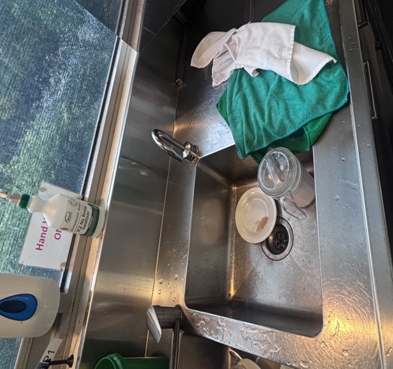 | Fig. 2  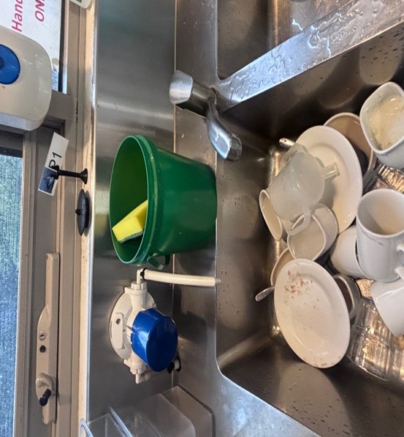 | Fig. 3 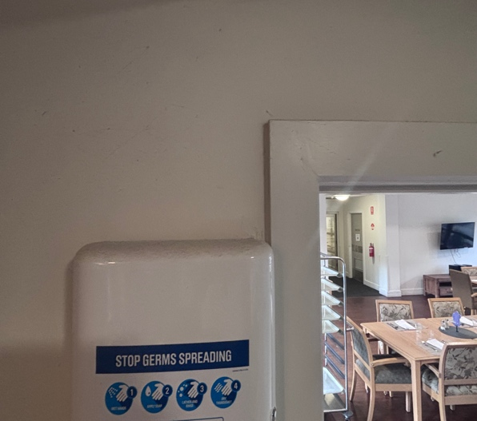 | Fig. 4  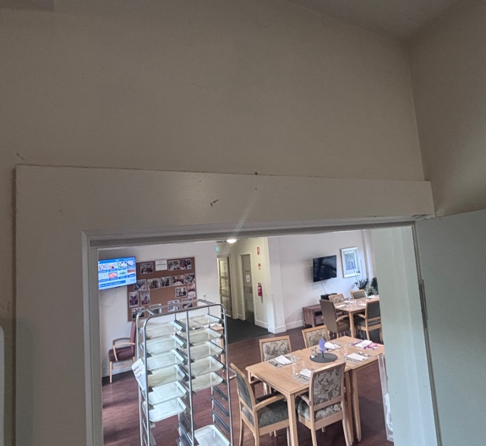
Fig. 5  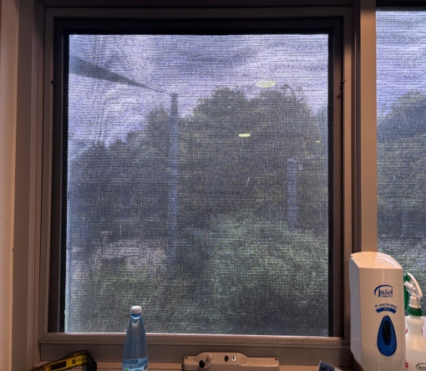 | Fig 6  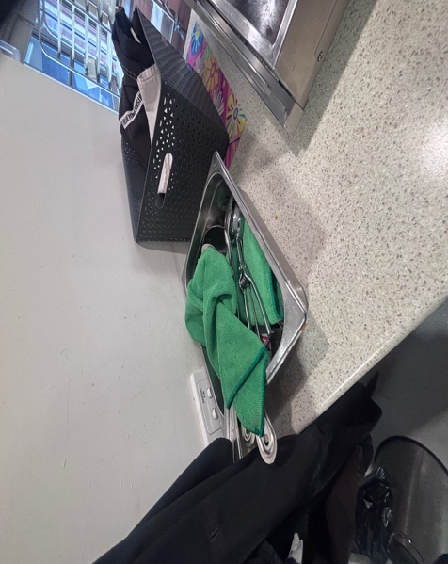 | Fig. 7  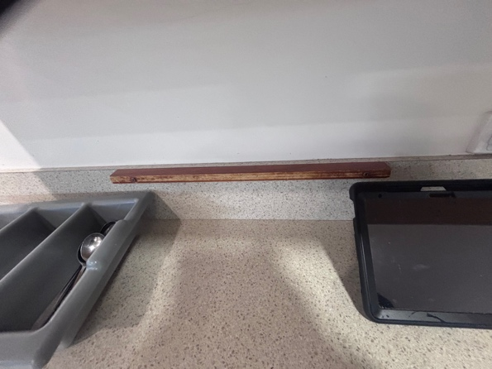 | Fig. 8  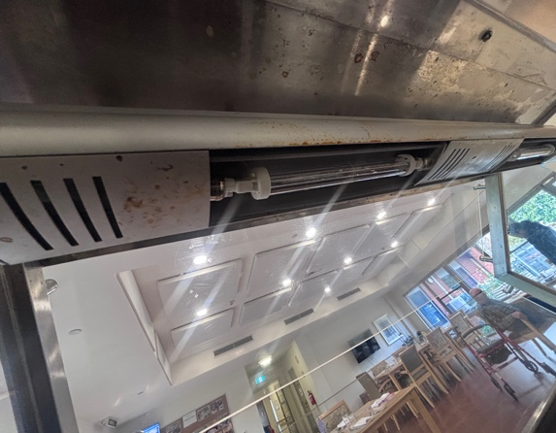
Fig. 9  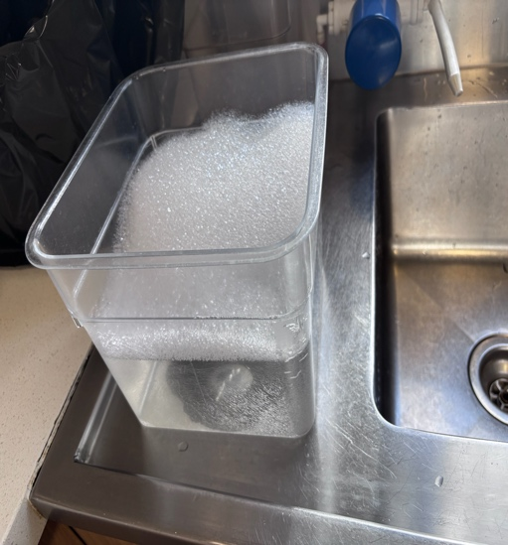 | Fig. 10  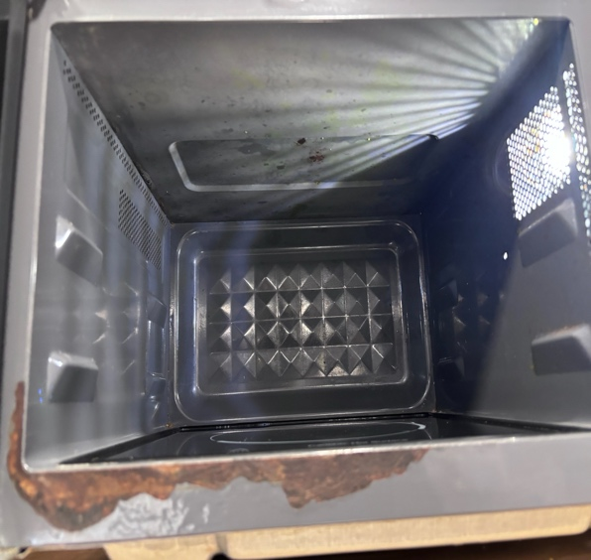 | Fig 11.  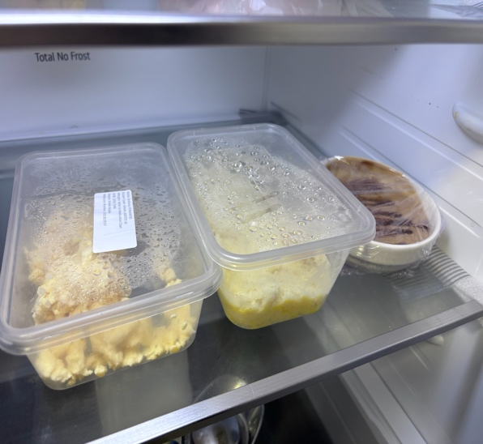 | Fig. 12  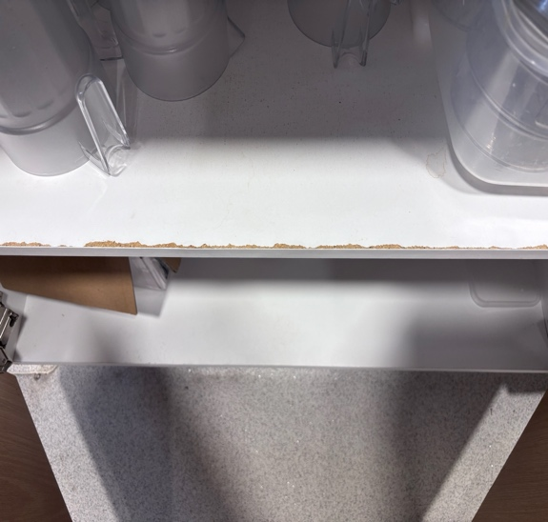
Fig. 13  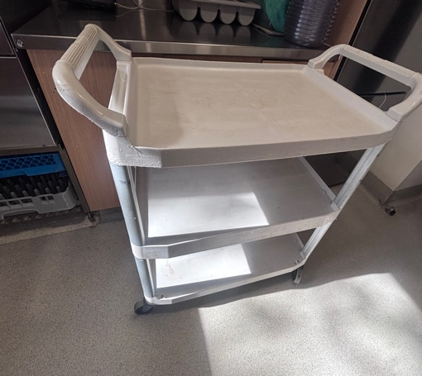 | Fig. 14 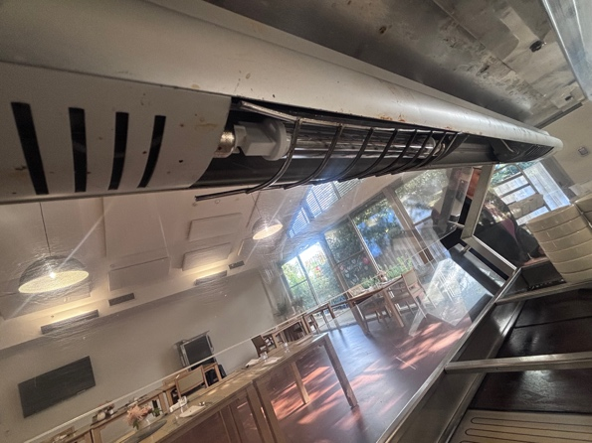 | Fig. 15 | Fig. 16  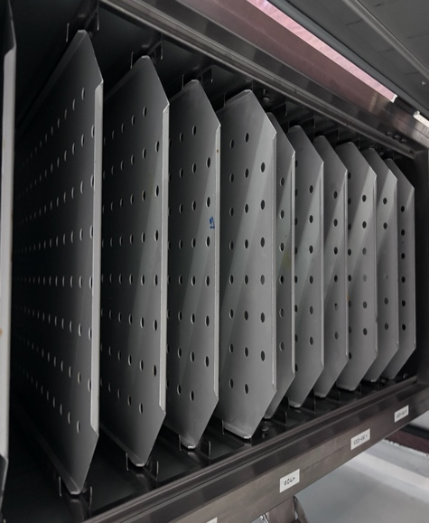
Fig. 17  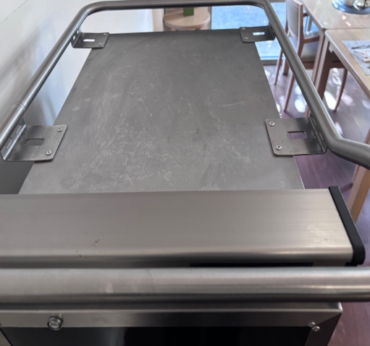 | Fig. 18 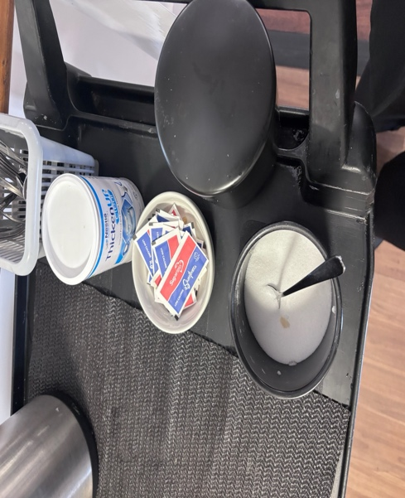 | Fig. 19  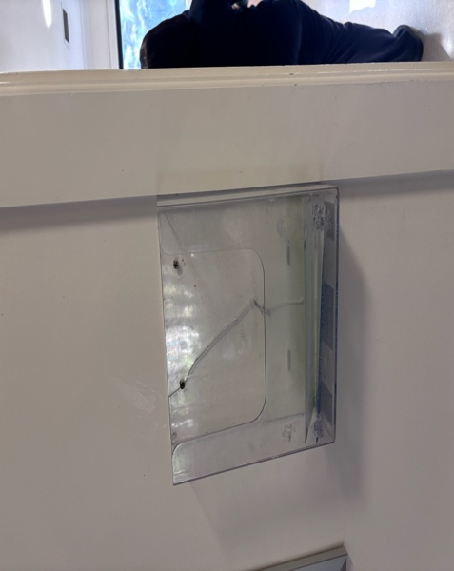 | Fig.20  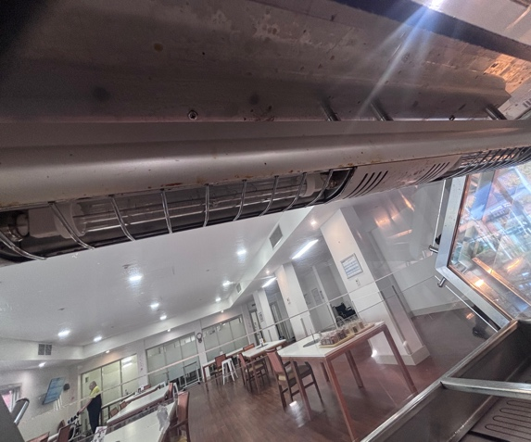
Fig 21.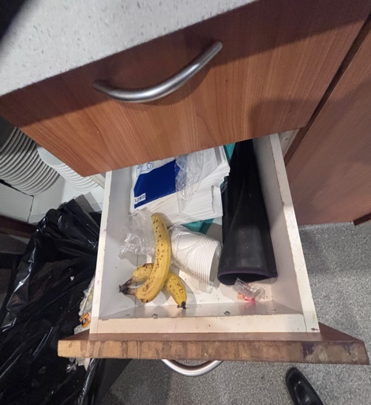 | Fig. 22  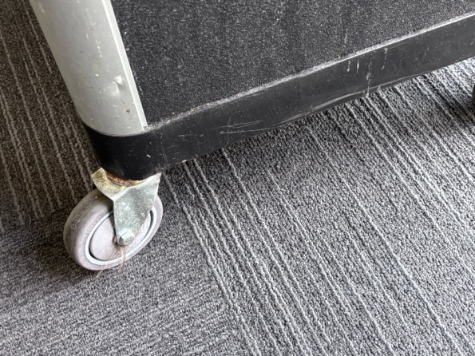 | Fig. 23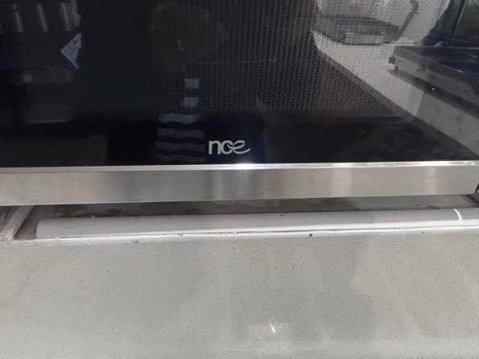 | Fig. 24 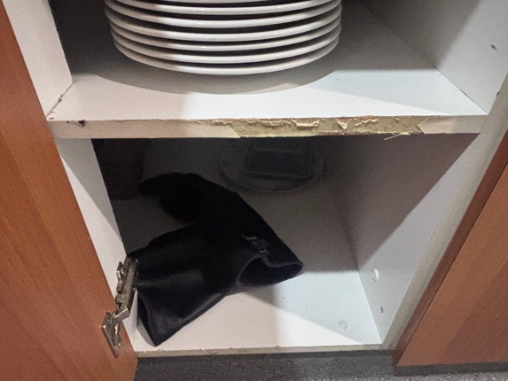
Fig 25  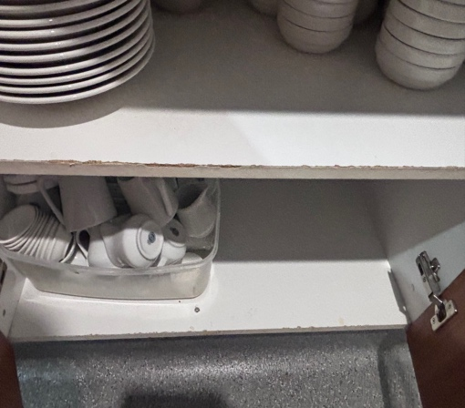 | Fig 26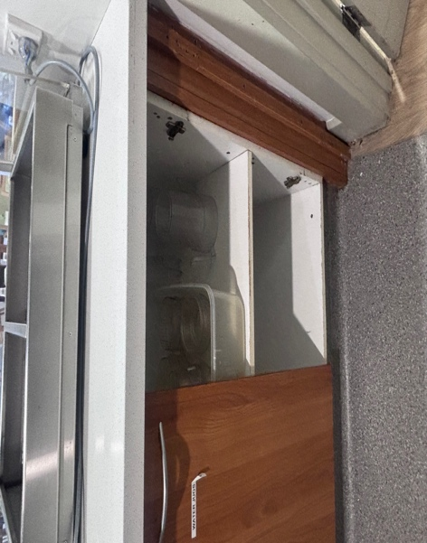 | Fig 27 | Fig 28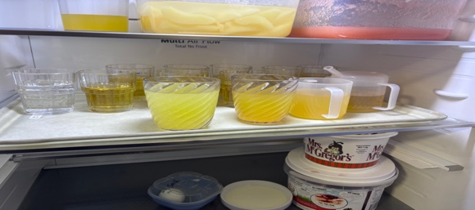  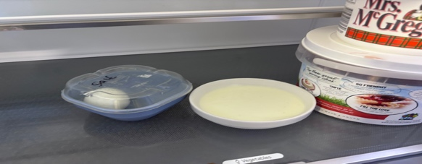
Fig 29  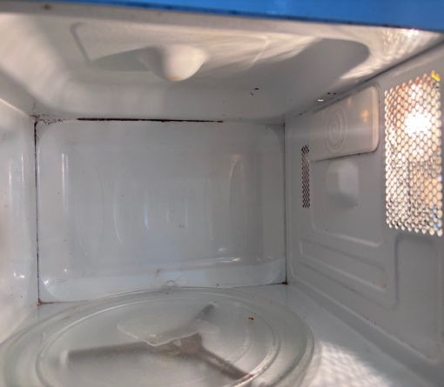 | Fig 30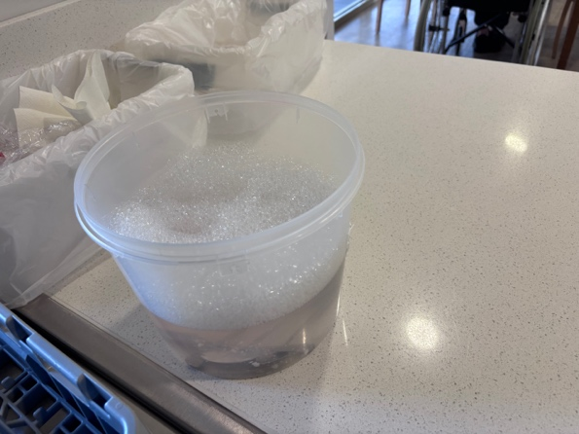 | Fig 31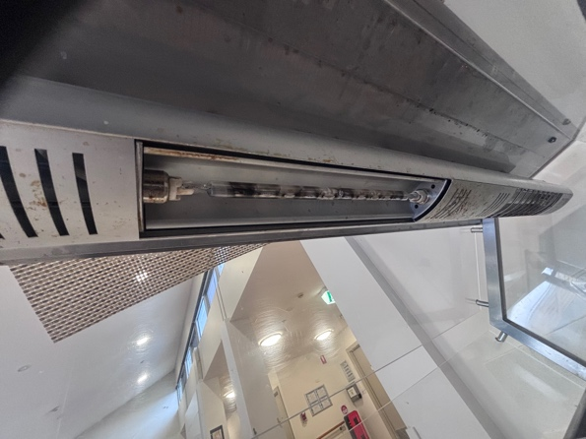 | Fig 32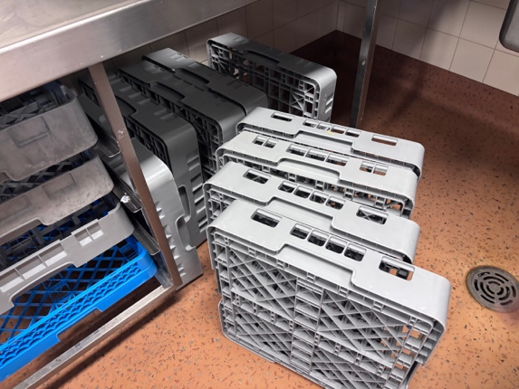
Fig 33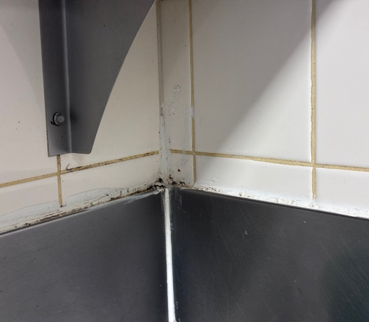 | Fig 34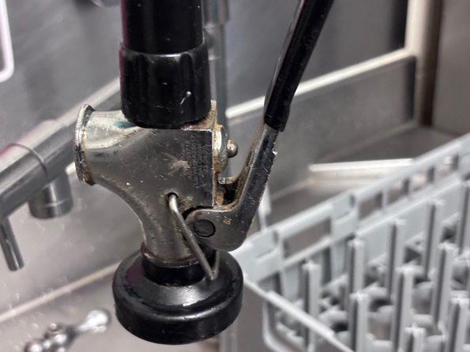 | Fig 35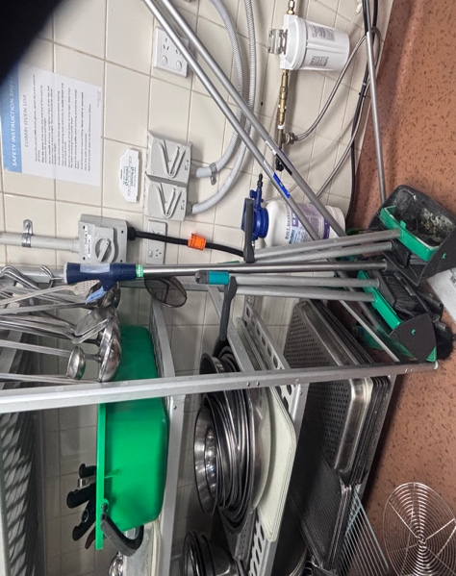 | Fig 36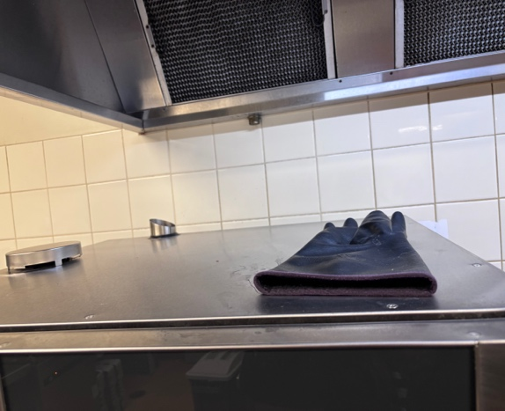
Fig 37  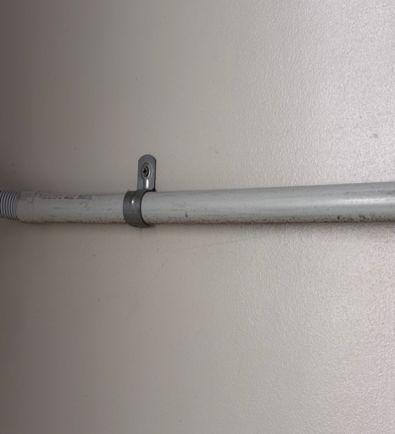 | Fig 38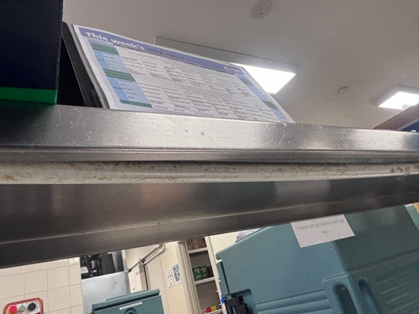 | Fig 39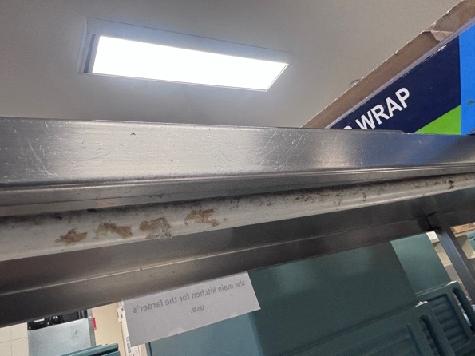 | Fig 40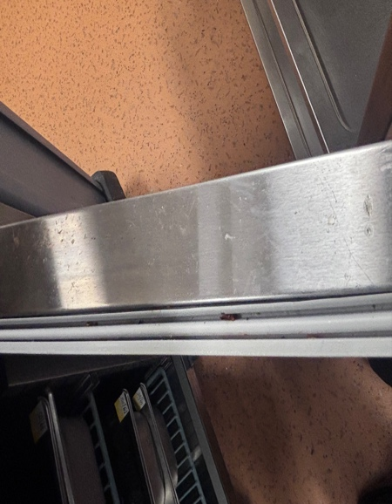
Fig 41  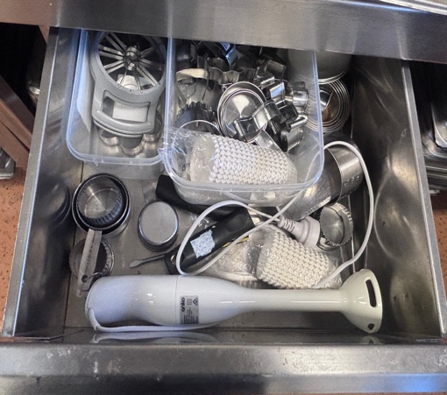 | Fig 42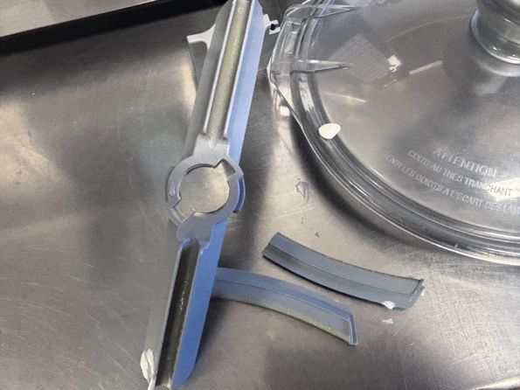 | Fig 43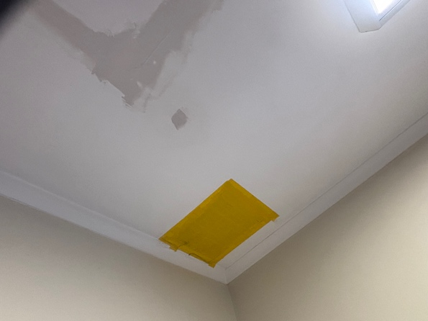 | Fig 44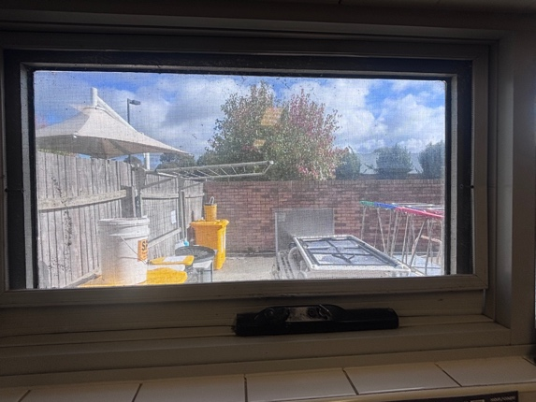
Fig 45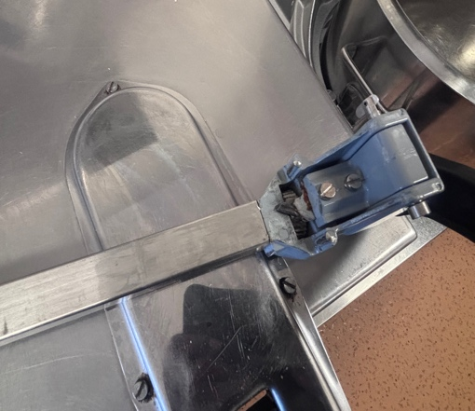 | Fig 46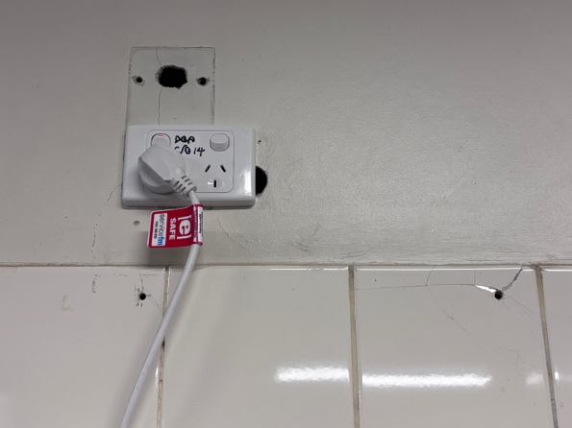 | Fig 47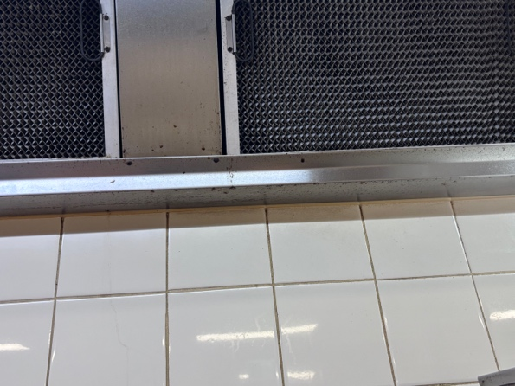 | Fig 48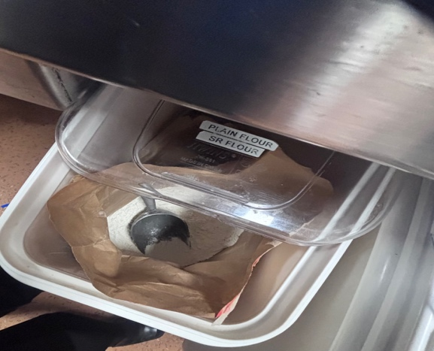
Fig 49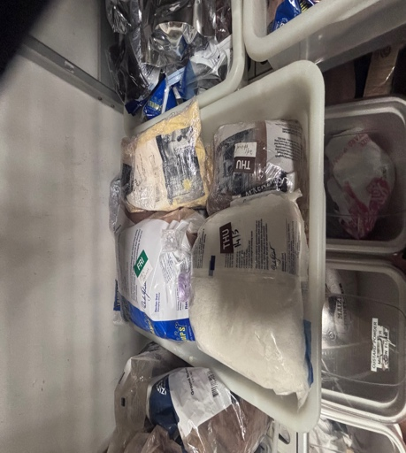 | Fig 50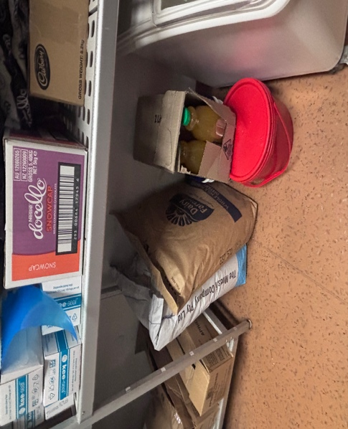 | Fig 51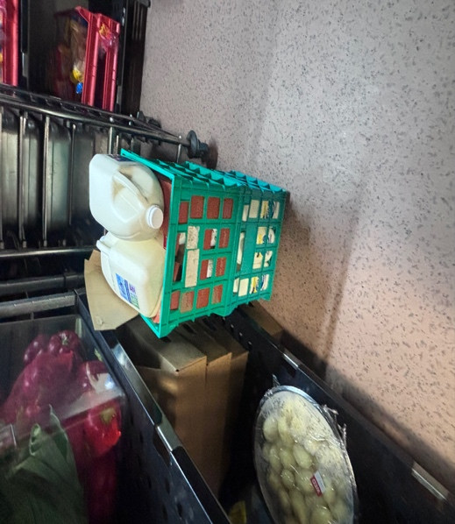 | Fig 52  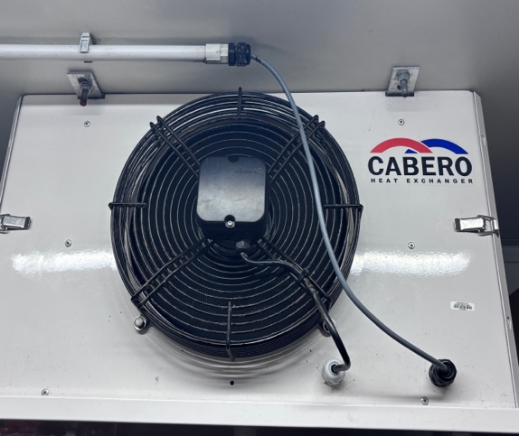
Fig 53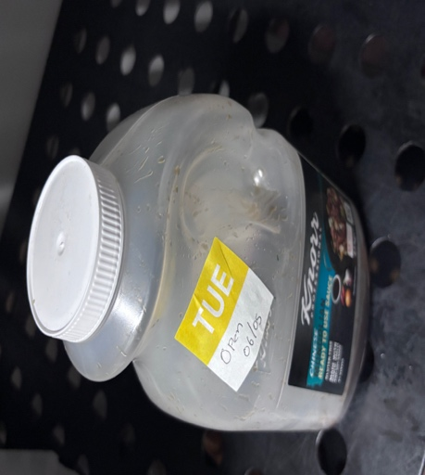 | Fig 54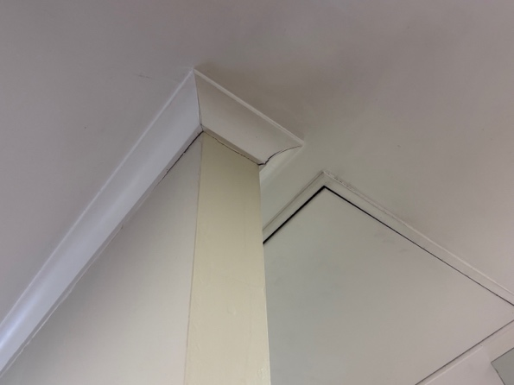 | Fig 55 | Fig 56

AUDIT CONCLUSION
The facility demonstrated several positive food safety practices, including the implementation of a simple digital temperature monitoring system, maintenance of regular temperature monitoring records, and the use of dedicated storage arrangements for resident meals. Staff were observed to have access to hand washing facilities, food storage equipment, and cleaning resources necessary to support food safety operations.
However, the audit identified three non-conformances relating to cleanliness, maintenance of food premises and equipment, food storage practices, and protection of food from contamination. Several areas of the facility exhibited inadequate cleaning, including visible accumulations of dirt, grease, residue, grime, mould, and food debris on equipment, fixtures, and structural surfaces. A number of damaged or deteriorated surfaces, including exposed timber, cracked coving, damaged storage units, and worn equipment components, were also identified and may hinder effective cleaning and sanitising. Additional concerns were noted regarding food storage practices, date labelling, chemical segregation, and the protection of food and utensils from potential contamination.
The identified non-conformances require corrective action to ensure ongoing compliance with the Food Standards Australia New Zealand (FSANZ) Food Safety Standards. Continued focus on cleaning effectiveness, preventive maintenance, food storage controls, and environmental hygiene will further strengthen the site's food safety management system and reduce the risk of food contamination.
Items raised under observations must be addressed and followed up at the next internal audit to verify that appropriate corrective action has been implemented and that improvements have been sustained.
Thanking Aurelie and the team at Regis Dandenong North for their cooperation and engagement throughout the audit process.

The information stated by me in this report and accompanying this report is true and correct to the best of my knowledge and does not contain anything that is false or misleading in a material.
Signature  Date 04/06/2026

